**Conway’s Game of Life – Performance Metrics**

In order to successfully perform an analysis of the efficiency and optimization of the system we looked at the two user inputs separately, holding one constant and manipulating the other. To analyze the impact of iterations on the execution time of the program, starting positions was held at a constant 65, approximately the middle of the possible inputs. The collected data and graph is shown below:

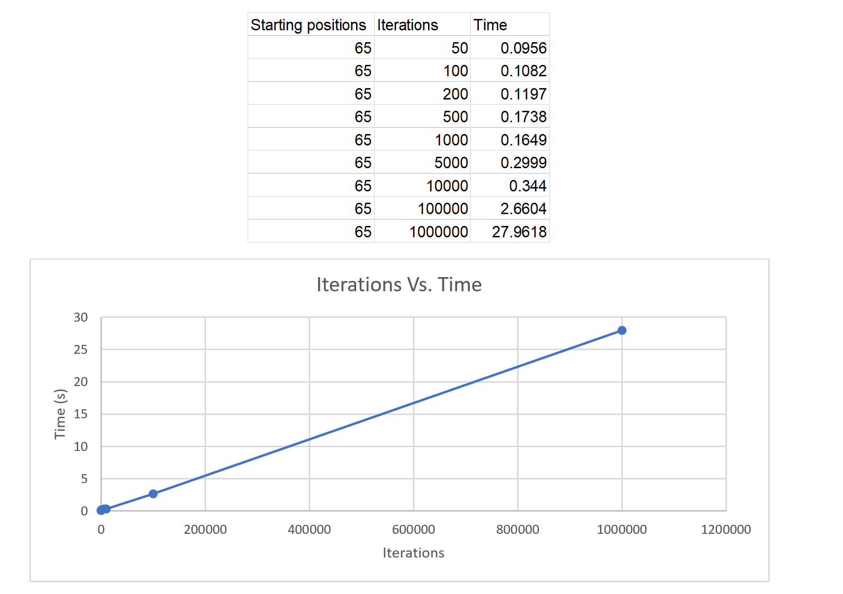

Based on our data collected, it is apparent that iterations have a linear relationship with the amount of time it takes for the program to execute. This makes sense simply because our program Is simply repeating all the steps, there is not a sample size that decreases or something along those lines that would cause it to have an exponential or logarithmic relationship.

To analyze the effect of the amount of starting positions on execution time we followed a similar procedure as iterations. In this case we held iterations at a constant 1000 to allow our data to only show how the starting positions impact the execution time. The data and graph is shown below:

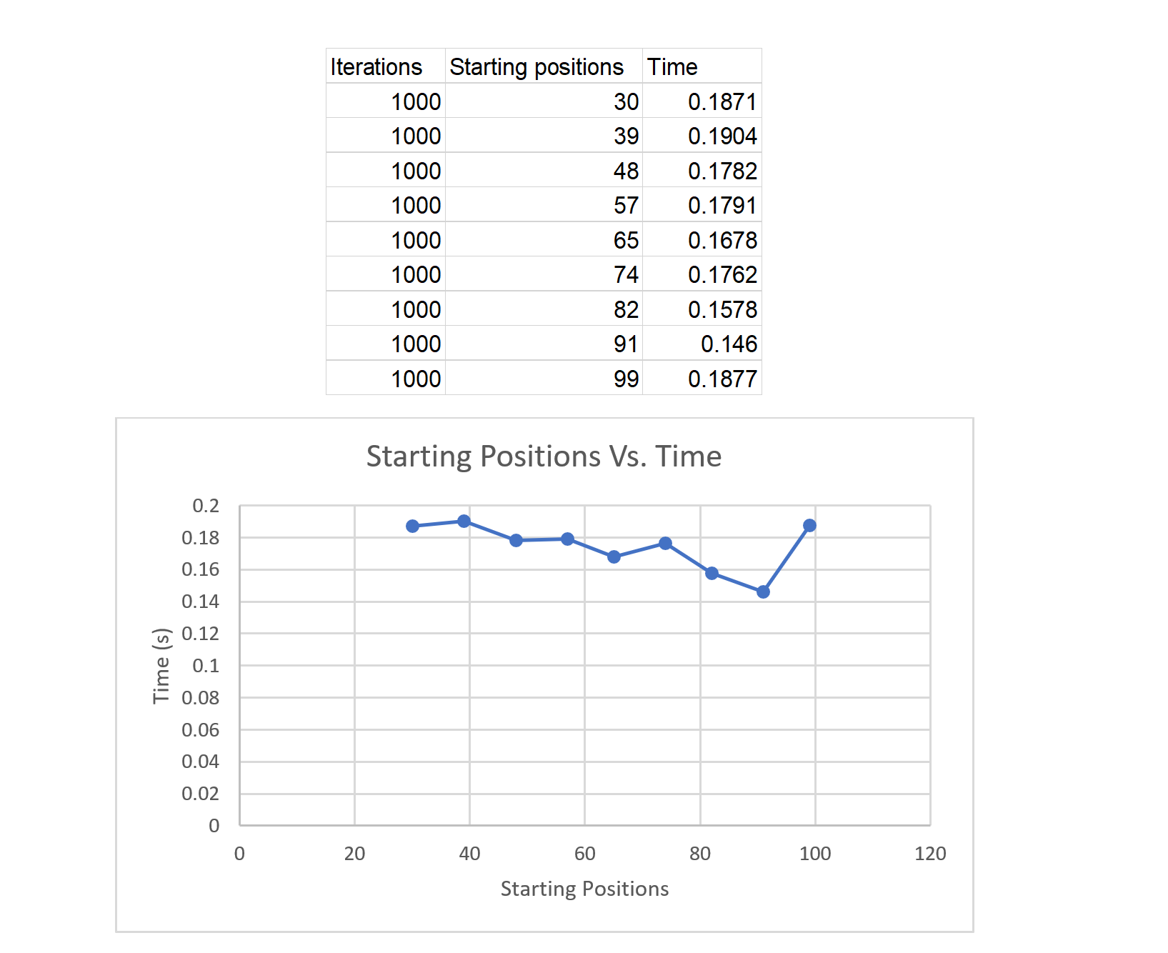

The graph shown above does not seem to follow any specific trend, besides a slight overall decrease in execution time. The apparent randomness is due to the inherent randomness of life, and in turn Conway’s Game of Life. Increasing the number of starting positions will not necessarily mean an increase in execution time, because if there are not any other starting positions close enough or in the right spot the cell will die. This means that execution time relies not only on the amount of starting positions, but the position itself and whether other “living” cells are in the right position relative to each other.

If we were to perform these tests again, we may consider finding a way to more accurately analyze how starting position, in all its aspects, impacts the execution time of our program.